# Laserfiche Forms Summary Tool

1. Go to http://nalabr005/Forms/
2. Click on “Reports” in the ribbon at the top of the page.

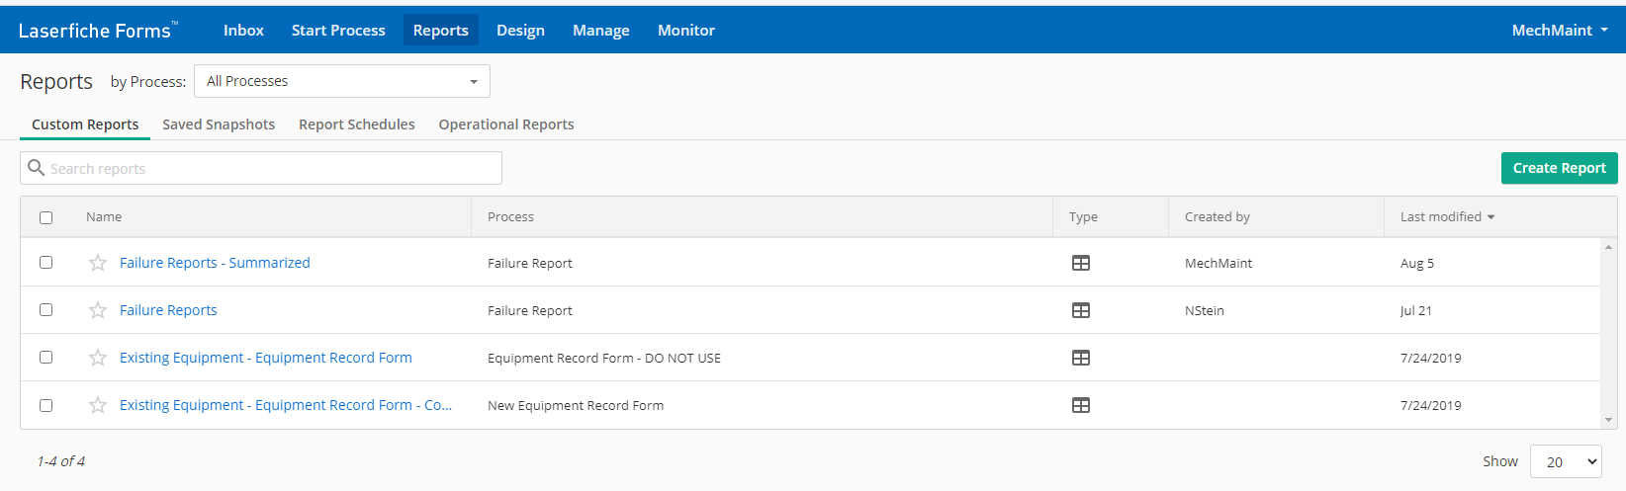

1. From there you can view
   1. “Custom Reports” – Reports where you can customize what data they pull in and how they display that data.
   2. “Saved Snapshots” – You can save a copy of any of your custom reports. This allows you to easily see what a report looked like on a specific date.
   3. “Report Schedules” – You can set up schedules that will email a set number of people a copy of a report or a link to a report on a reoccurring basis.
   4. “Operational Reports” – You can view the status of all the reports that are from a given Form Process.

## Making or Editing a Custom Report

1. Under the “Custom Reports” heading, click the create report button in the upper right.
2. Select a report type. This guide will use the Table type. 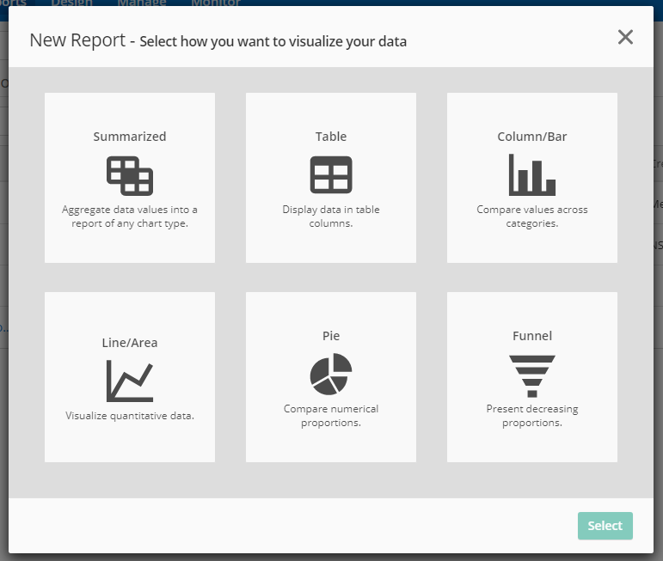
3. Select the Forms Process or Processes that you want to pull data from. 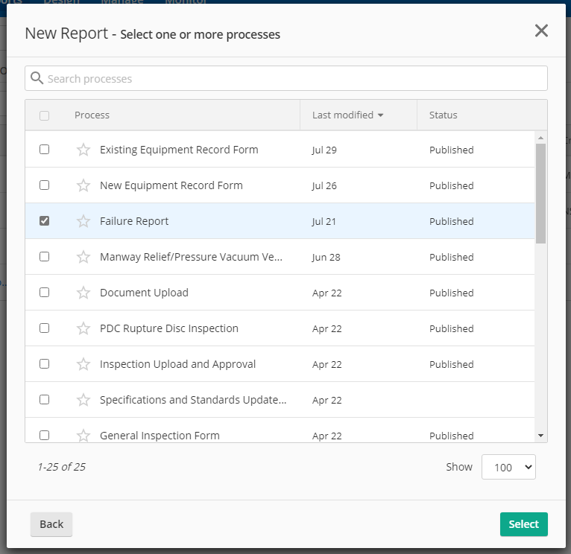
4. Determine who view the report and give it a name. 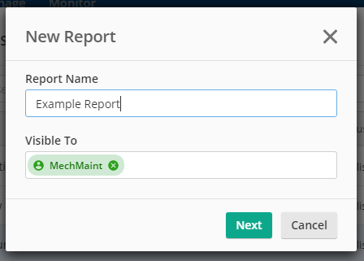
5. You should now see the following screen where you can customize your report. 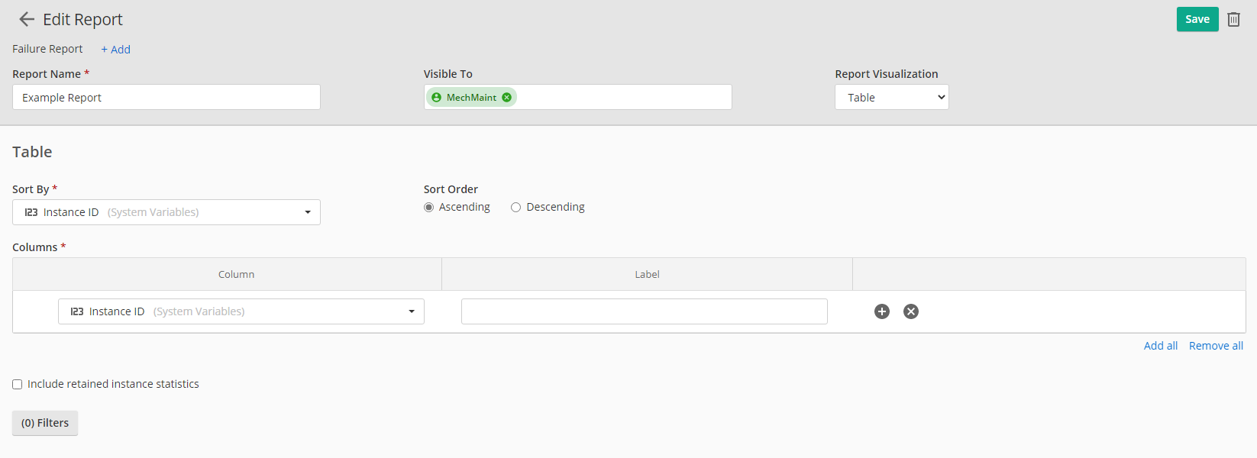
6. Add the columns you want to see on the report.
   1. Select fields from the drop down menus under “Column”.
   2. If you want you can add custom labels to be used for the column in the report under “Label”.
   3. You can add or remove columns using the +/x buttons on the right

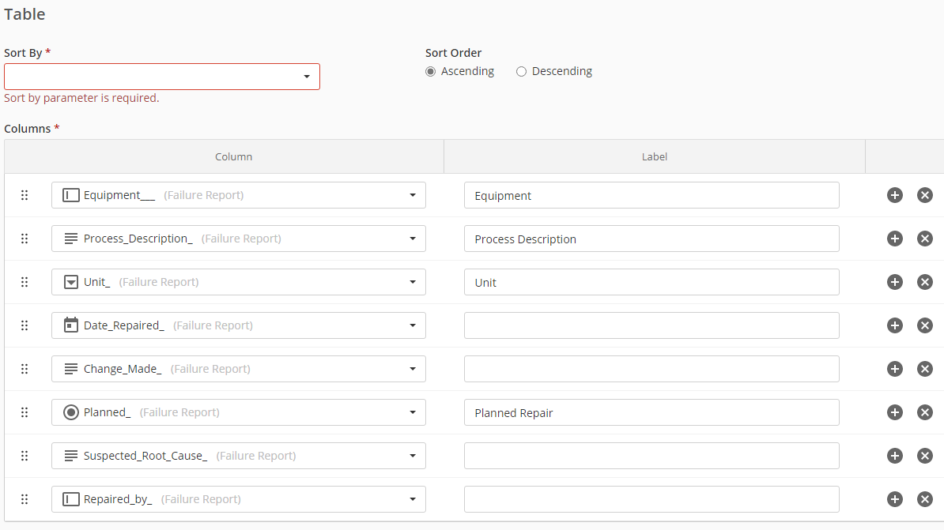

1. Select what you want to “Sort By”
   1. You can use any of the fields that are filled out in the Forms Process or Processes that you are pulling data from. And select either Ascending or Descending sort order.

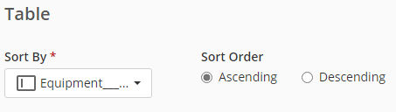

* 1. If you wish to add more Processes you can do so by clicking the +Add button at the top next the Forms Processes you are already using.

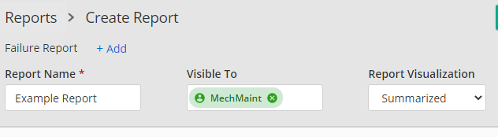

1. To add filters, click the button at the bottom of the screen that says (#) Filters. Then click the “+ Add Filter” button.

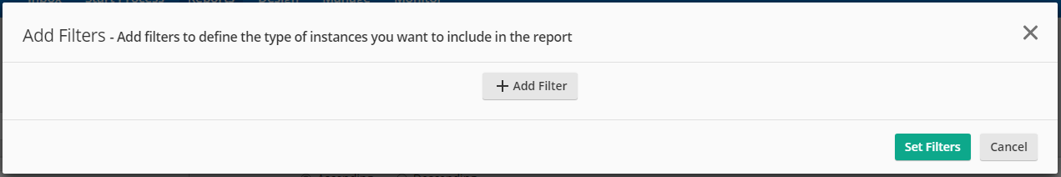

* 1. You can select any “System Variable” or one of the Fields from the Failure Report to filter by.
  2. Then from the middle area you can select what kind of match you want
  3. If needed, then enter the value you wish to match against

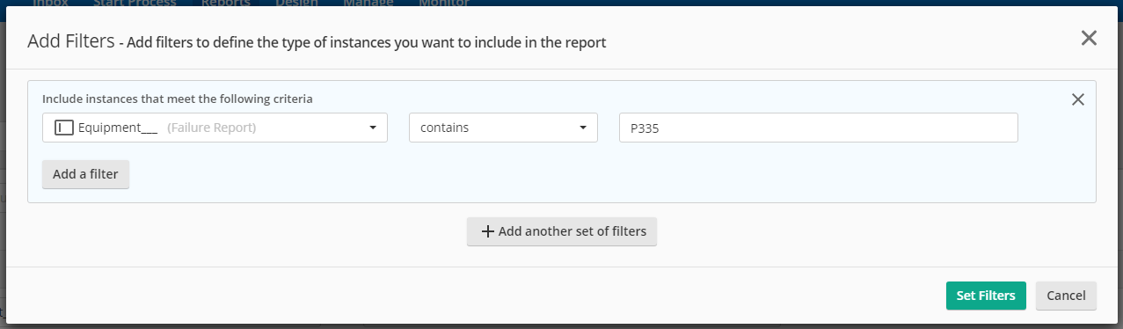

1. To add a filter where the selection must meet both or all the requirements (aka AND statement between filters) click the “Add Filter” within the box of the set of filters you want to add to. 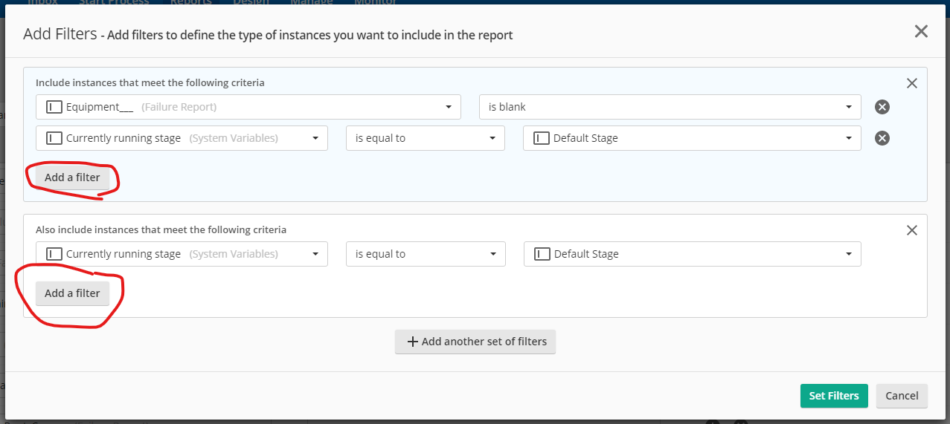
2. To create a separate filter (aka OR statement between filters) click the “Add another set of filters” button. This will create a new set of filters that won’t interact with other sets. 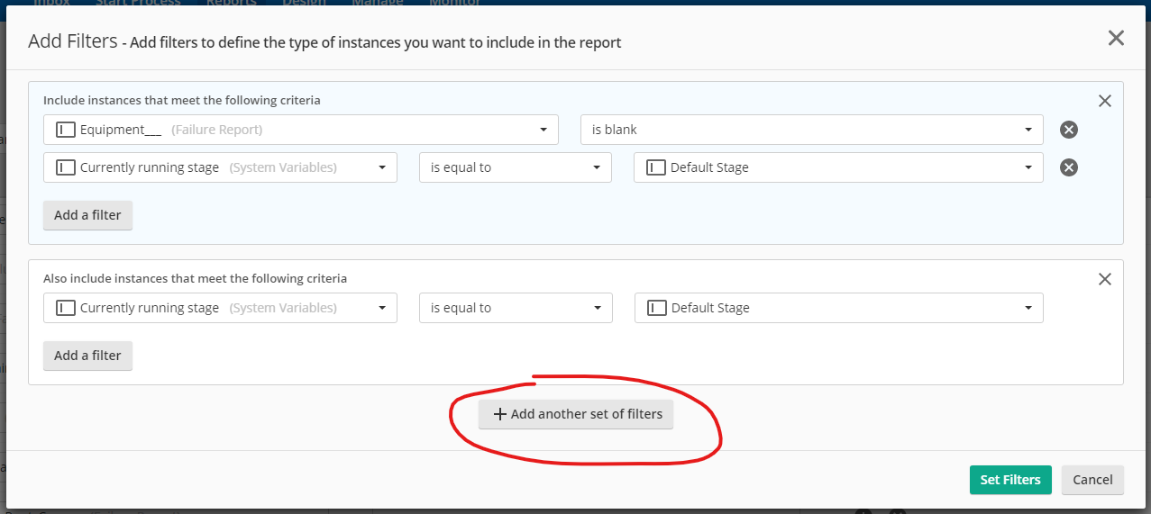
3. To finish creating the report, click “Create in the upper righthand corner.
4. To edit later on click open report in Laserfiche forms and click Edit in upper left corner. 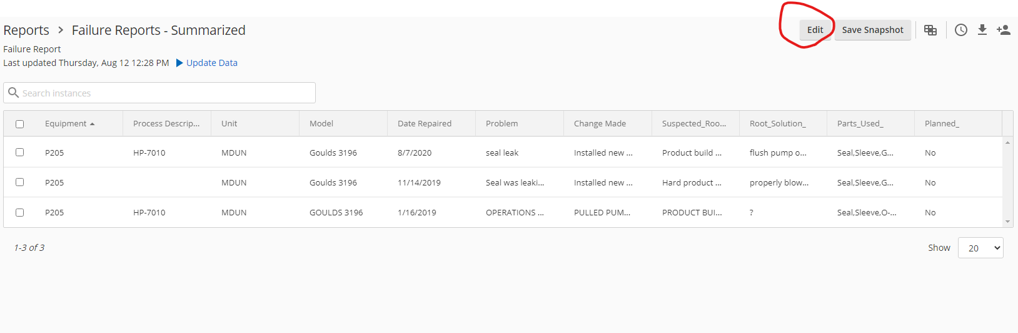
5. To save snapshot click “Save Snapshot” next to “Edit” button.
6. To create schedule either got to “Report Schedules” tab of reports or click on the clock icon in the upper left of the Report page.
7. When downloading be sure to uncheck “Include choices details” unless you want dropdown menus to show up as each option being a column name and a 0 or 1 telling you if that option was selected.

